**Email 1b:** Company CEO Welcome  
**From:** Company CEO, Leader, or Employee Campaign Chair’s first and last name **Audience:** All company employees

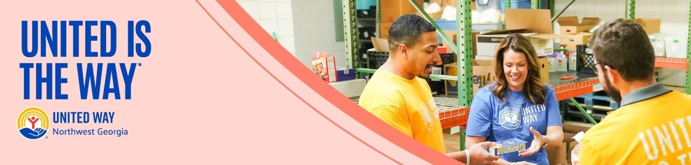

**Subject Line:** [COMPANY NAME] Team, please join me in supporting our neighbors in Whitfield and Murray counties   
**Email Body:**

[NAME],

At [COMPANY NAME], we believe in giving back to the communities where we live and work. That’s why I’m proud to support our friends at United Way of Northwest Georgia– and I’m inviting you to join me.

Every day, United Way – with the support of community-minded partners, volunteers, and donors like us – is working hard to ensure that everyone has access to essential services and resources they need to thrive, including:

* Nutritious food and quality health care our neighbors need to lead healthy lives.
* Childcare, early learning, education, and enrichment to set kids up for success from cradle to career.
* Counseling, career training, and housing support to help families not only make ends meet, but create a sustainable financial future.
* Emergency preparedness and their 211 helpline help ensure that our community stays connected, strong, and resilient, no matter what challenges we may face.

Please consider making a one-time or recurring gift to support this powerful work and send a message of solidarity and compassion to our neighbors most in need. Together, we can make a transformative impact in our community.

**United is the Way™.**

[Insert information about how they can donate]

BUTTON TEXT: Give Today [Hyperlink to donation page]

Thank you in advance for your generous support.

Sincerely,

[NAME]