**Email 4a:** General Thank You to All Employees  
**From:** Your United Way CEO/CPO, Board or Campaign Chair’s first and last name **Audience:** All company employees

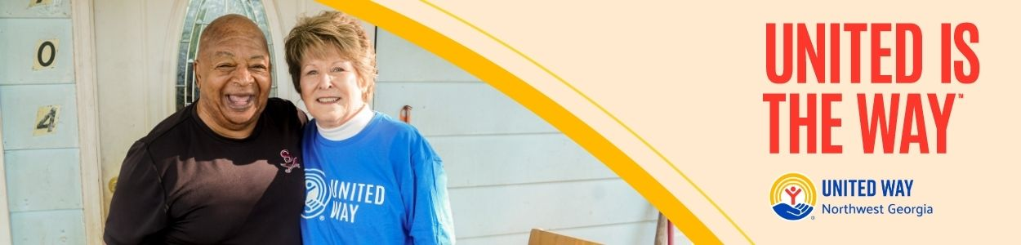

**Subject Line:** [COMPANY NAME], thank you for your impact!

Dear [NAME],

Join me in celebrating the success of the 2025 [COMPANY NAME] United is the Way employee giving campaign.

I’m thrilled to report…[Customize your overview impact remarks. Specific metrics are suggested below.]

• [COMPANY NAME] employees gave $ [DOLLARS PLEDGED] to United Way of Northwest Georgia

• [PARTICIPATION RATE%] of [COMPANY NAME] Employees gave to United Way of Northwest Georgia

• [NUMBER OF DONORS] of [COMPANY NAME] employees gave to United Way of Northwest Georgia

• [Company Name] employees contributed more than [NUMBER OF VOLUNTEER HOURS] volunteer hours during the campaign.

Let’s continue changing lives and transforming communities in Northwest Georgia!

**United is the Way™.**

BUTTON TEXT: See Your Impact [Hyperlink to campaign report or webpage with impact metrics]

Sincerely,

[NAME]