**Email 4b:** Targeted Thank You to Campaign Donors   
**From:** Your United Way CEO/CPO, Board or Campaign Chair’s first and last name **Audience:** Company employees who donated to United Way (not designated to other organizations)

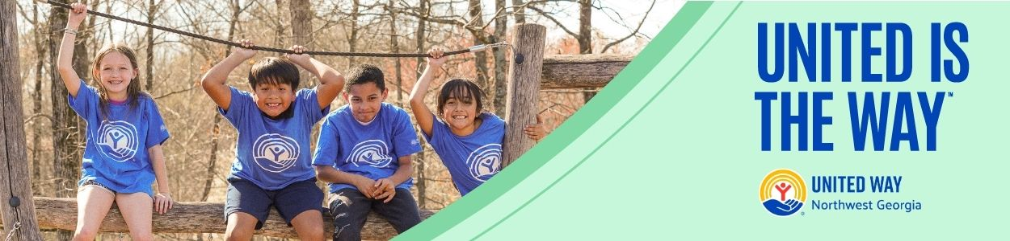

**Subject Line:** [NAME], thank you for giving back!

Thank you for your generous gift to United Way of Northwest Georgia. Your donation is making a real difference in people’s lives. Today and every day, we need you with us. Here are ways that you can continue making our community a better place:

* **Volunteer**: Make a difference by volunteering. Our Volunteer Center is ready to help you and your company make an impact. Reach out to us to schedule your volunteer project today!
* **Speak Out**: Encourage your neighbors and colleagues to become active in our community and raise your voice on the issues that impact hard-working families in Whitfield and Murray counties.
* **Stay in the Loop:** Sign up for our email newsletter to keep informed about what we’re doing across Northwest Georgia and how you can stay involved.

Thank you again for your generosity and commitment to our neighbors. Together, let’s continue to create thriving communities for all.

**United is the Way™.**

**BUTTON TEXT:** Stay Involved [Hyperlink to <https://www.ourunitedway.org/newsletter-signup>]

Sincerely,

[NAME]